Database Management Systems Lab Work

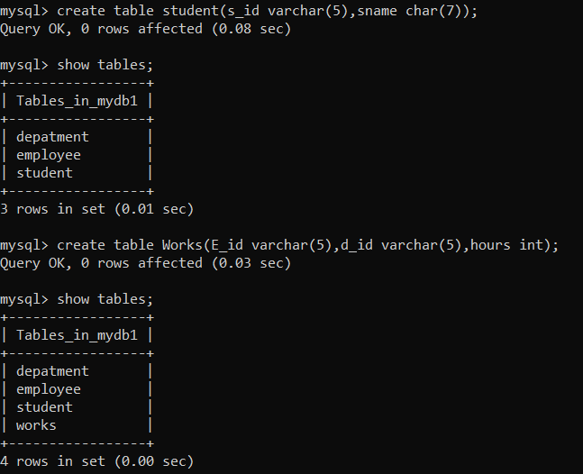

1.Insert 5 rows in each table.

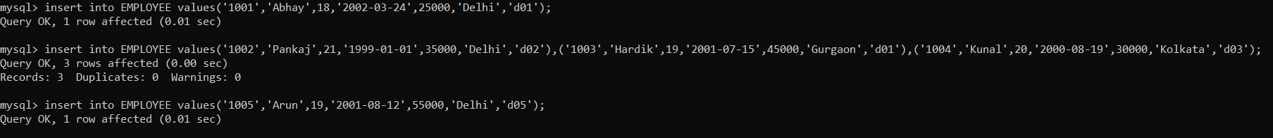

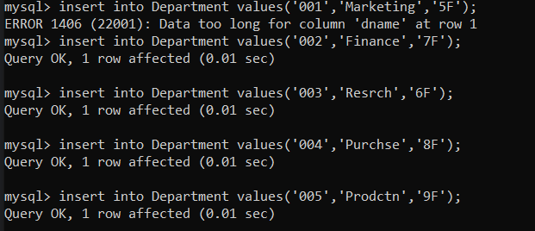

2.Increase size of column city to 10 in table Employee

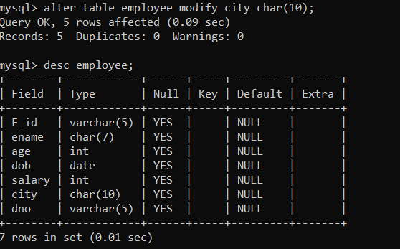

3.Rename table department to office

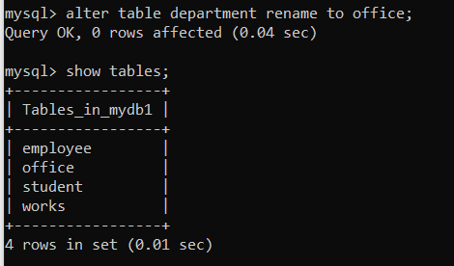

4.Drop the table Student

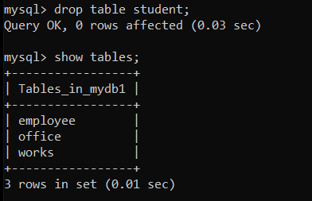

5.Delete the data of employee in department number 1

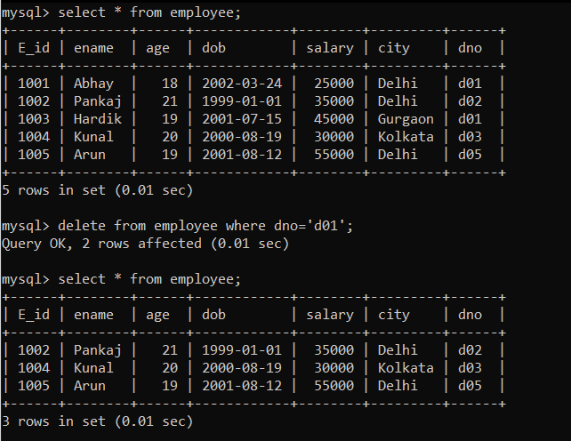

6. Increase the salary by 10% of those employees having salary less 32000

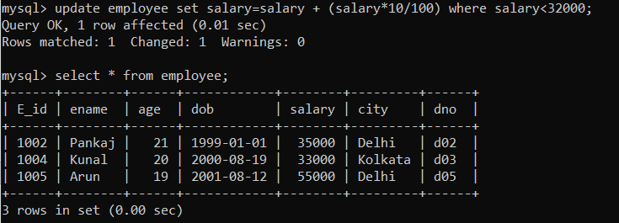

7. Add a column State with char(10) in the table Employee

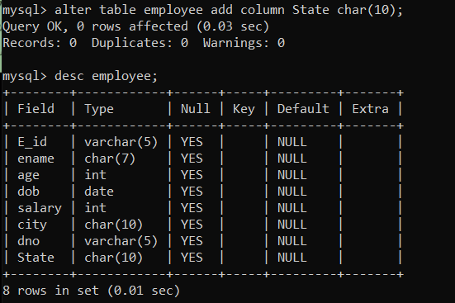

8. Now insert values for the new added column state in the employee table.

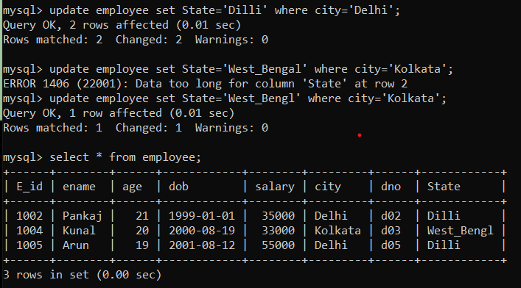



9. Change the name of city in employee to address

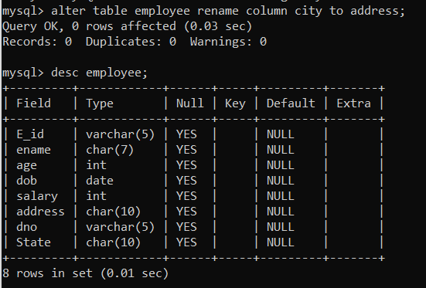

10. Add a column manager_id with varchar(5) in the table department

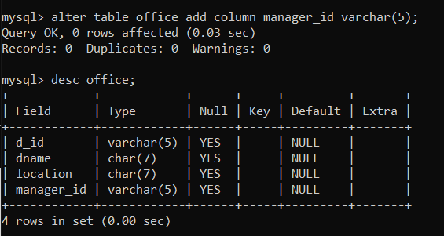

11. Now insert values for the newly added column manager_id in the department table

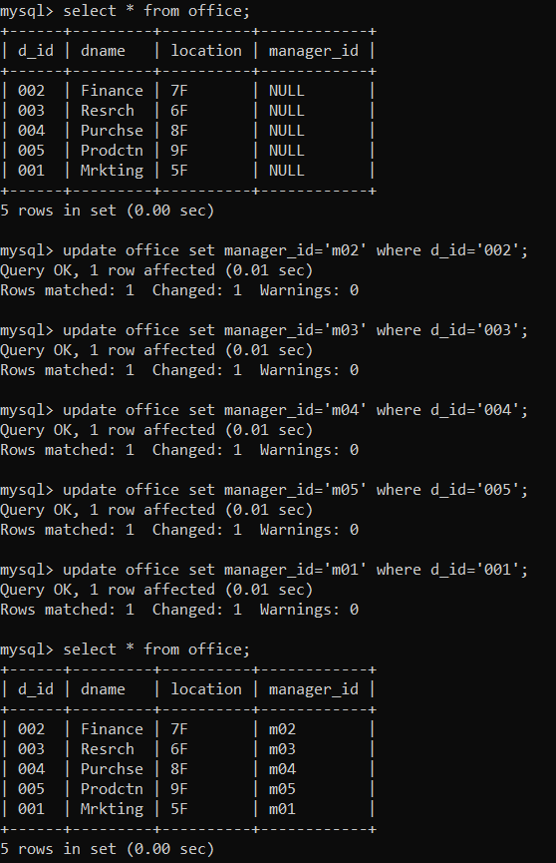

12. Drop column age from Employee

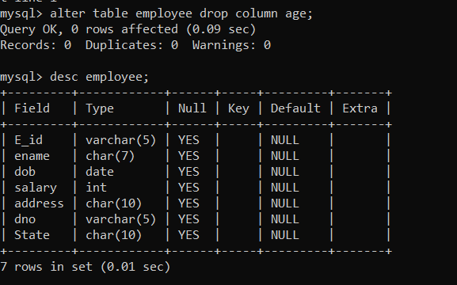

13. List of Employee who have salary greater thn equal to 20000 and less than equal to 50000

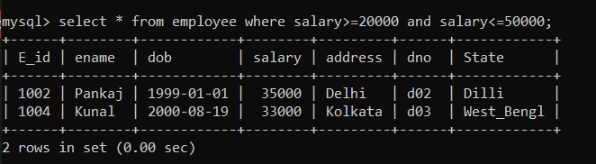

14. List down the Departments located at 8F

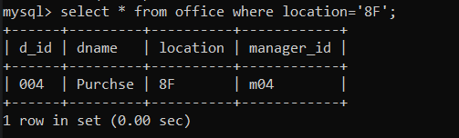

15. List the eid, name of those employees whose name starts with letter a and ends with letter a.



16. List those employees who are having age greater than 19 yrs and are residing in Delhi.

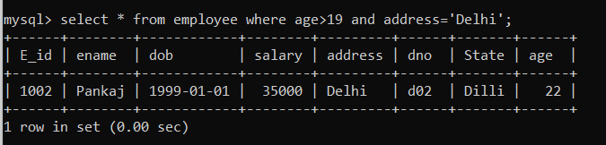

17. List the eid ,age,name of employees living in either Delhi or Kolkata using in predicate.

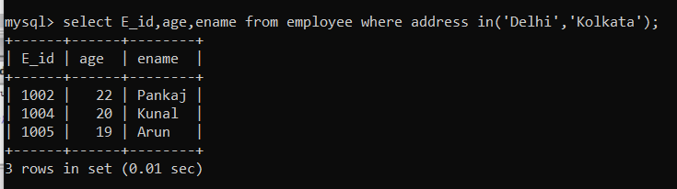

18. List the details of the departments whose location name has second character as p and second last character as F.

